**Social Marketing Overview Course Test**

Thank you for taking the "Social Marketing Overview” course. Part of the requirements is that you take a test and complete an evaluation of the course. Please answer the questions on the following pages. There are 15 questions and to receive the certificate you must pass with at least 70% (7) correct (multiple choice correct responses get partial credit). If you have questions please contact Jim Grizzell at jim@healthedpartners.org.

**Scoring and Submitting Answers**

Your total score is calculated as you answer questions and is shown on the last page. Instructions for submitting your answers are on that page also.

**Contact and Certification/License Information**

Please provide contact information. **First** and **last** **names** and **email** **address** are required. These, at least, are needed for your certificate and emailing it to you.

**First Name:\*** _______________________________

**Last Name:\*** _______________________________

Address: _______________________________

Address 2: _______________________________

City/Town: _______________________________

State:

ZIP Code: _______________________________

Country: _______________________________

**Email Address:\*** _______________________________

Phone Number: _______________________________

Provide the name or names of your certification, registration or, license name and number. This will be used on your certificate of passing the course. Example: CHES 19198

Certification, registration or, license name and number: _____________________________

Certification, registration or, license name and number: _____________________________

Certification, registration or, license name and number: _____________________________

**Test Questions**

1. According to the MMWR article “Prevalence of Self-Reported Physically Active Adults – US, 2007 what percent of the BRFSS survey respondents met the 2008 Guidelines and HP2010 objectives?

. A.

. B.

. C.

2. In Richard bit.”

True . False .

3. In Dr. Troiano’s PowerPoint presentation he listed “Major Conclusions”. What are they (mark all that apply)?

. A. Regular activity reduces risk of many adverse health outcomes

. B. Some activity is better than none

. C. Added health

. D. Most

4. In chapter 1

True . False .

5. The

True . False .

6. The

. A. Aerobic:

. B. Muscle-

. C. Bone-

7. The Key

. A.

. B. For

. C. For

. D. Adults

8. Like the

True . False .

9. The chapter

True . False .

10. The Key

. A. Adults

. B. Adults

. C. When

. D. Adults

**Overall Evaluation**

Please evaluate this distance learning / self-study course.

|  |  |  |  |  |  |
| --- | --- | --- | --- | --- | --- |
|  | **Strongly agree** | **Agree** | **No opinion** | **Disagree** | **Strongly disagree** |
| Overall, I would rate this activity positively. |  |  |  |  |  |
| The activity effectively targeted my needs. |  |  |  |  |  |
| The activity was appropriate for my Knowledge/skill level. |  |  |  |  |  |
| The format (e.g., readings, audio) of the course was effective. |  |  |  |  |  |
| The presenter(s) appropriately addressed issues of diversity. |  |  |  |  |  |
| The activity met my expectations. |  |  |  |  |  |
| Learning the content will positively impact how I work. |  |  |  |  |  |
| I would recommend this activity to a colleague. |  |  |  |  |  |

How well did the course meet the following learning objectives?

|  |  |  |  |  |  |
| --- | --- | --- | --- | --- | --- |
|  | **Not at all met** | **Not very well** | **Adequately met** | **Very well** | **Extremely well** |
| Define definitions and key concepts of social marketing. |  |  |  |  |  |
| Describe how a manager can help staff conduct social marketing process. |  |  |  |  |  |
| Explain upstream social marketing. |  |  |  |  |  |

Will you change the way you practice as a result of the course?

Yes . No .

If yes, please describe how or what you will do your work differently.

Type here

Please give comments and suggestions to improve the course.

Type here

**Please go to next page for your score and instructions for submitting test responses.**

**Thank you for completing the test.**

Here is your total score (you can return to the questions and change answers):

Be sure to save this file with answers to your computer. **Now** you will need to **submit** your answers to get credit for successfully passing the course. The Submit button is in the upper corner of the window in which the form is open.

**“SUBMIT” INSTRUCTIONS** – It depends on your email program. If you use Microsoft Outlook as your email program the form data should be sent automatically when you click the “Submit” button. If, however, you use another email program such as gmail or yahoo you would have to save the pdf form to your computer then attach it to an email to [ce@healthedpartners.org](mailto:ce@healthedpartners.org). Here is a dialogue box to look for immediately after clicking the submit button that should be in the upper right corner of the window where the test is open.

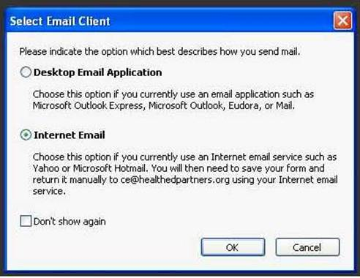

**Course Evaluation** - Remember to complete the course evaluation. The link to the evaluation is on the 1st page of the Study Guide and www..

If you have any questions or would like to provide comments please send them or call me using the contact information below. Feel free to ask questions or get additional help from me.

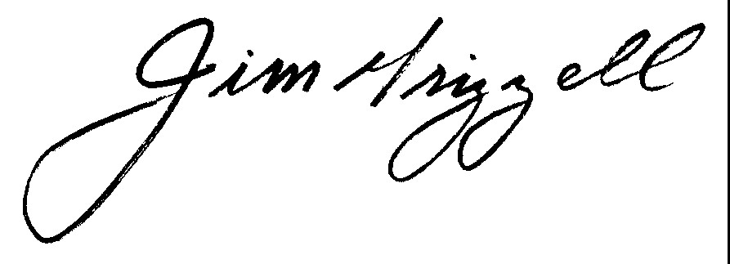

Jim Grizzell, MBA, MA, CHES, ACSM-HFS, FACHA

E - [jim@healthedpartners.org](mailto:jim@healthedpartners.org)

C - 909-856-3350

W – [www.healthedpartners.org](http://www.healthedpartners.org)

W - [www.csupomona.edu/~jvgrizzell](http://www.csupomona.edu/~jvgrizzell), <https://experts.csupomona.edu/expert.asp?id=120>

Correct answers are on the next page.

**Correct Answers**

1. A. is correct. Percentages for B are for women. C has the percents for people without a high school diploma
2. True
3. All are correct. Each worth 0.11%.
4. True
5. True
6. All are correct. Each is worth 0.333%
7. All are correct. Each is worth 0.25%.
8. True
9. True
10. All are correct. Each is worth 0.25%.
11. All are correct. Each is worth 0.2%
12. True
13. True
14. True
15. True