***Using Social Marketing for Health Promotion and Health Education Programs***

Self-study course with 10.5 Cat 1 CECHs (4.5 advanced) for CHES/MCHES

|  |  |  |
| --- | --- | --- |
| General Information | Instructor:  Email:  Phone:  Project Tools: | Jim Grizzell, MBA, MA, MCHES, ACSM-EP-C  [jimgrizzell@healthedpartners.org](mailto:jimgrizzell@healthedpartners.org)  909-856-3350 (cell, please call between 8 am - 9 pm Pacific Time)  All materials available online. Best pdf reader for this course is Adobe Reader . |
| ***Course Description*** | **Directed Self-Study:** a learning experience on social marketing in which the learner participates without regard to time or location. This is an offering that consists of seven learning modules with quizzes plus an assessment (test) to be submitted for scoring and credit. It includes computer-based, prepackaged learning; videos; peer-reviewed, journal-based articles; and published educational/informational materials (government, reports, etc.). | |
| ***Course Objectives*** | You will be able to describe the structure and content of *CDCynergy Social Marketing Edition (version 2)* and be able to use it in your own in your work environment. You will be able to make a problem description; do market research; develop a market strategy; develop interventions; plan monitoring and evaluation of the interventions; and implement and evaluate the intervention. | |
| ***Course Requirements*** | *Study Materials:* CDCynergy Social Marketing Edition (free on web)  *30-Question Multiple Choice Assessment*  *Course Evaluation* | |
| **Course planning tool is CDCynergy Social Marketing Edition Web page available at:**  **Web Page:** [www.orau.gov/cdcynergy/soc2web/default.htm](http://www.orau.gov/cdcynergy/soc2web/default.htm)  A CD with all the materials can be purchased from Health Education Partners for $35 (includes shipping). Contact Jim Grizzell. NOTE: CD is not required for completion of the course. | | |
| **The entire course will be done electronically using the web and email.**  Here are links to course home page, syllabus and test:  [www.healthedpartners.org/ceu/sm](http://www.healthedpartners.org/ceu/sm)  **30-question multiple choice post-course assessment (required, includes evaluation).**  <https://www.surveymonkey.com/r/hehp-planning-socialmarketing> | | |
| ***Course Completion Certificate*** | Course completion certificate for 10.5 (includes 4.5 advanced, shaded learning objectives) continuing education contact hours (CECH) the will be awarded if a score of at least 70% (21 of 30) is achieved and the Course Evaluation is completed. | |

|  |  |
| --- | --- |
| **Estimated Time** | **Instructions, Activities and Objectives** |
| ~1 hour | **CDCynergy Welcome and Introduction**  After studying this section, the participant will be able to access and use the program and be able to explain concepts of social marketing:  ***Follow detailed start instructions on page 5*** to read, and view and listen to the following:  **NOTE:** New versions of RealPlayer may not play the videos. Please see information about updated videos at bottom of this page.   * Opening video * Welcome * How to Use   + - Welcome and Menu     - Approaching the Social Marketing Edition       * “Introduction to Social Marketing"     - Approaching the Social Marketing (Video Segments), History of CDCynergy, Primer for Managers, Is Social Marketing for Your?, Phases and Steps |
|  | ***Instructions for remainder of the self-study course***   1. Read text for each Step (there are 30 in all) of each of the six Phases 2. View and listen to videos in each step (39 totaling 3.3 hours)      1. Click on icon and read or study “Need More Detail” 2. Click on link, read and study the **Examples** as provided   **Example:**  [The Violence Against Women campaign](http://www.orau.gov/cdcynergy/soc2web/Content/phase01/phase01_step03.htm) viewed service providers for non-English speaking and Aboriginal males as a key secondary audience.   1. Click on icon and read or study hyperlinked items. These are charts, graphs, definitions, web pages such as [CDC Health Protection Goals](http://www.cdc.gov/osi/goals/goals.html). 2. Click on icon and correctly answer question at the end of each Step  1. Click on icon and read “Evaluation Relevance” which explains how each step relates to the evaluation process (Phase 5) |
| **NOTE:** New versions of **RealPlayer** may not play the videos. Converted videos are at:  [www.healthedpartners.org/ceu/sm/Cdcynergy/Content/activeinformation/videos/SOC_videos.htm](http://www.healthedpartners.org/ceu/sm/Cdcynergy/Content/activeinformation/videos/SOC_videos.htm) | |
| ~1.5 hour | **Phase 1: Problem Description**  After studying the material in this Phase the participant will be able to:   * State your health or safety problem and the groups it affects * Identify the major causes of the problem by analyze and identifying factors that foster or hinder learning and skill building * Draft a list of possible audiences for participants program * Learn about previous efforts to address the problem * Form a strategy team by identifying stakeholder to participate in the assessment process * Identify issues and aspects of participants situation that could affect the program’s success |
| ~1.5 hours | **Phase 2: Market Research**  After studying the material in this Phase the participant will be able to:   * Spell out participants market research questions * Select research methods to answer those questions * Take full advantage of data that were collected for other purposes * Collect supplementary data * Synthesize and summarize your research results |
| ~2 hours | **Phase 3: Market Strategy**  After studying the material in this Phase the participant will be able to:   * Select your target audience segment(s) * Define the current and desired behavior for each segment – increasing levels of the desired behavior is their program goal by using assessment results to inform the planning process and develop goal statements * Identifying the benefits of the desired behavior to “doers” in each segment * Clarify the exchange participants will offer and encourage * Assess efficacy of various strategies to ensure consistency with objective by Appling a marketing mix analysis to select the intervention’s for their program * Select a variety of strategies and interventions to achieved stated objectives * Write sub-goals for each intervention that will add up to their overall program goal |
| ~1.5 hours | **Phase 4: Interventions**  After studying the material in this Phase the participant will be able to:   * Describe what your services and products will actually look like * Explain how your program will phrase its messages * Explain how your various offerings will be tied together into a cohesive, mutually reinforcing whole * Assemble your planning team and assign roles * Plan your interventions in detail by organizing in a logical sequence and with a timeline for delivery * Test and revise your interventions |
| ~2 hours | **Phase 5: Monitor Plan**  After studying the material in this Phase the participant will be able to:   * Develop an analysis plan and determine which program components should be monitored and/or evaluated * Create a purpose statement and develop evaluation questions for * Decide how to gather the information * Decide how to analyze and report the data (disseminate findings) * Explain how to get IRB approval for research with human subjects if necessary |
| ~1 hour | **Phase 6: Implementation**  After studying the material in this Phase the participant will be able to:   * Describe how you will execute intervention plans * Describe initiation of monitoring and evaluation activities (Develop an analysis plan and determine which program components should be monitored and/or evaluated) * Explain how you will modify program components based on feedback * Describe how you will share evaluation findings and lessons learned |
| <1 hour | **Take 30 Question Test and Complete the Course Evaluation**  Evaluation questions are included after the last test question.  The test has 30 multiple choice questions.  **Name, Certification & ID#, Email Address:** Be sure provide your name and CHES/MCHES or other certificate type **plus** ID/registration number that should be on your completion certificate. Give email address so your completion certificate can be emailed to you.  **How to Take the Test:** You can go back and change answers even after you complete the test. You can "Exit" the test and return to answer more questions (only on this device (computer, laptop, cell phone; a cookie allows this).  After the last test and course evaluation questions you will see your score with percent correct and test answers. If you scored less than 70% you can retake the test.  **Notifying Health Education Partners of Test Completion:** After you complete the test a notification is automatically sent to Health Education Partners (but it arrives day after you complete the test). To ensure, however, Health Education Partners knows you completed the test complete the short form on the web page you will be taken to after clicking the last "Done" button. The link to that web page is: <http://www.healthedpartners.org/verify-course-completion.html>.  **Completion Certificates:** They are usually emailed to participants within 72 hours (most often same day) after notification the test was completed.  Complete the test online at this link:  <https://www.surveymonkey.com/r/hehp-planning-socialmarketing>  If you have any questions, contact Jim Grizzell at [jimgrizzell@healthedpartners.org](mailto:jimgrizzell@healthedpartners.org) |

**Step 1: Welcome and Introduction**

**NOTE:** New versions of RealPlayer may not play the videos in their current format. They have been converted and can be accesses at:

[www.healthedpartners.org/ceu/sm/Cdcynergy/Content/activeinformation/videos/SOC_videos.htm](http://www.healthedpartners.org/ceu/sm/Cdcynergy/Content/activeinformation/videos/SOC_videos.htm)

Start the course at this link: <http://www.orau.gov/cdcynergy/soc2web/default.htm>. You will see this web page. Click on **Click to Start** in the center of the page and view the opening video.

Each time you return to continue the self-study course on your own time after viewing the opening video to go to the main menu you only need to click on **Skip Intro**.

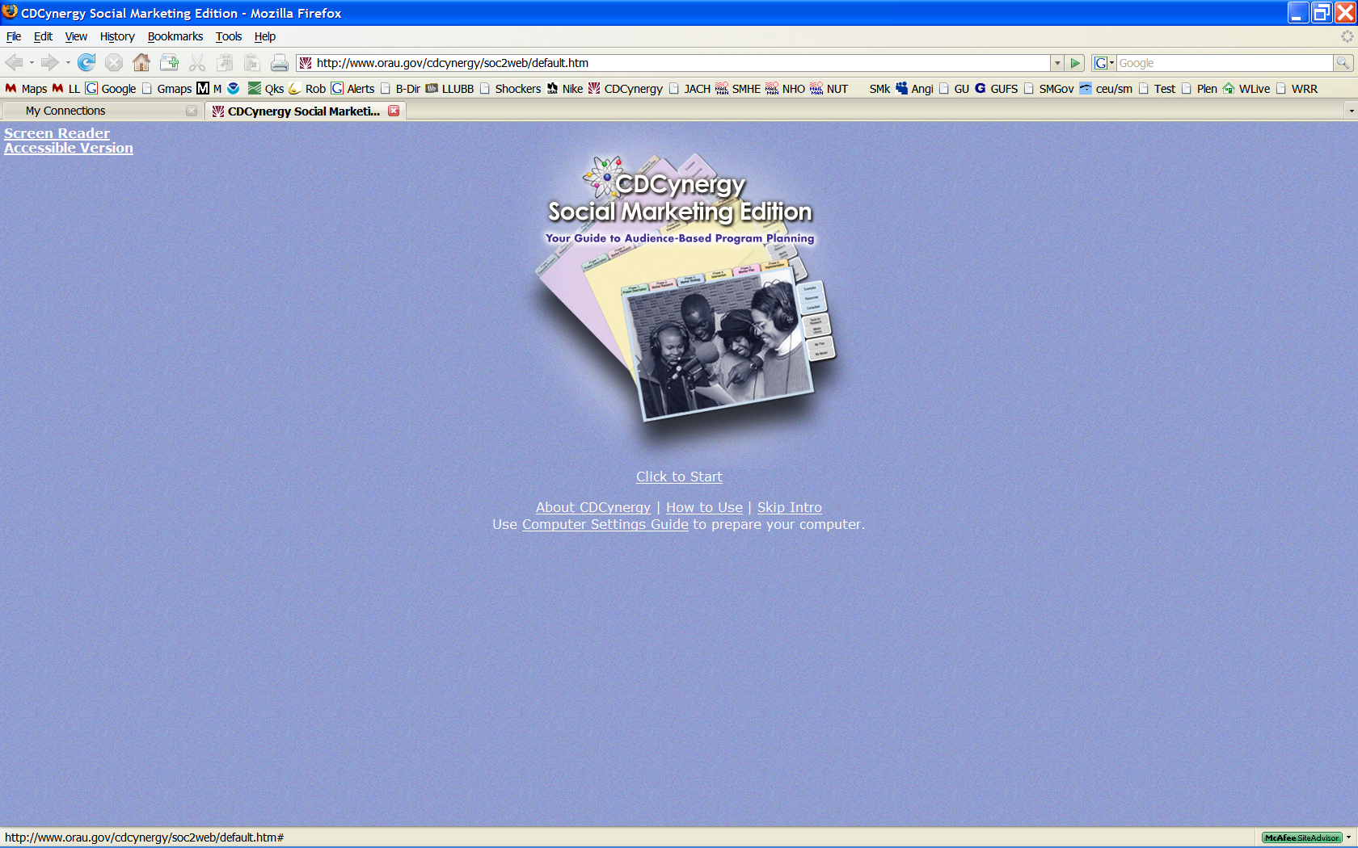

Note: if you have problems viewing videos click and follow the **Use** [**Computer Settings Guide**](http://www.orau.gov/cdcynergy/soc2web/settings_guide/settings_guide.htm) **to prepare your computer.**

After watching the opening video read text and view/listen to videos linked from each of the headings. These are **Welcome**, **How To Use**, **Acknowledgements** and **Introduction to Social Marketing**.

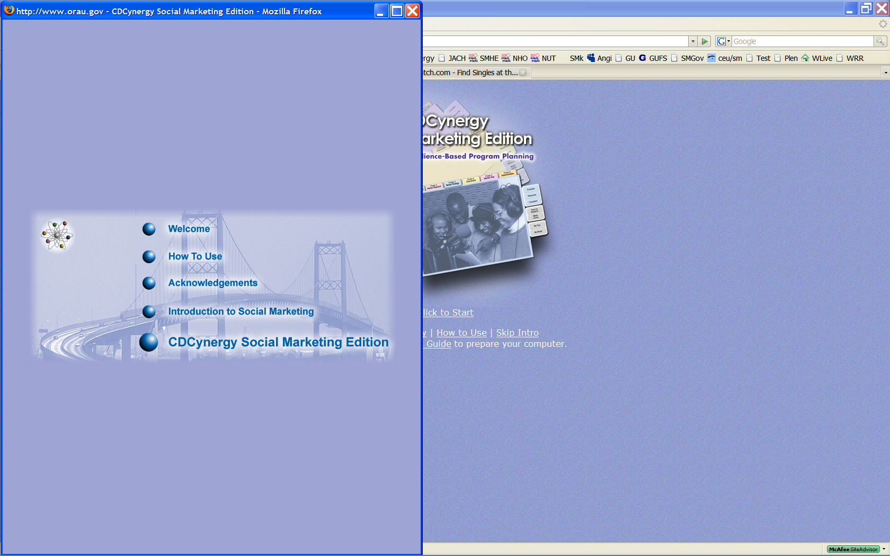

**Steps 2 through 7: Six Phase Tutorial**

***Instructions for remainder of the self-study course***

Click on **CDCynergy Social Marketing Edition**

1. Read text for each Step (there are 30 in all) of each of the six Phases
2. View and listen to videos in each step (39 totaling 3.3 hours)

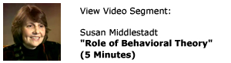

1. Click on icon and read or study “Need More Detail”



1. Click on link, read and study the **Examples** as provided. There are four examples which are case studies of audience-based program planning

**Example:**

[The Violence Against Women campaign](http://www.orau.gov/cdcynergy/soc2web/Content/phase01/phase01_step03.htm) viewed service providers for non-English speaking and Aboriginal males as a key secondary audience.

1. Click on icon and read or study hyperlinked items. These are charts, graphs, definitions, web pages such as [CDC Health Protection Goals](http://www.cdc.gov/osi/goals/goals.html).
2. Click on icon and correctly answer question at the end of each Step. There is immediate feedback so you will see the correct answer. Be able to explain the correct answer.



1. Click on icon and read “Evaluation Relevance” which explains how each step relates to the evaluation process (Phase 5)



To pass the final test (with at least a score of 70%) you should read the text on each page of each Phase’s Steps. You should view videos and related text in the “Example” sections, read each of the “NEED MORE DETAIL” resources. Each has links in many steps. Answer the “Test Your Knowledge” at the end of each Step throughout the course.**Links to Optional PowerPoint Presentations**

To view the document either press or hold the “Ctrl” button and left click with you mouse button or right click on the link and select “Open” from the menu.

**Social Marketing National Excellence Collaborative and Social Marketing 101**,

[www.healthedpartners.org/ceu/sm/01_social_marketing_nat_excell_collab_sm101.ppt](http://www.healthedpartners.org/ceu/sm/01_social_marketing_nat_excell_collab_sm101.ppt)

**CDCynergy Social marketing User Training Overview**

[www.healthedpartners.org/ceu/sm/02_social_marketing_cdcynergy_user_training_overview.ppt](http://www.healthedpartners.org/ceu/sm/02_social_marketing_cdcynergy_user_training_overview.ppt)

**Is Social Marketing for You?**

[www.healthedpartners.org/ceu/sm/03_is_social_marketing_for_you_v3.ppt](http://www.healthedpartners.org/ceu/sm/03_is_social_marketing_for_you_v3.ppt)

**Why Let the Devil Play All the Best Tunes – Let’s Use Social Marketing** – Presentation to the American College Health Association

[www.csupomona.edu/~jvgrizzell/socialmarketing/acha2008](http://www.csupomona.edu/~jvgrizzell/socialmarketing/acha2008)

**Upstream Social Marketing** – Presentation to the Wellness and Health Promotion Department of Arizona State University

[www.csupomona.edu/~jvgrizzell/socialmarketing/acha2008](http://www.csupomona.edu/~jvgrizzell/socialmarketing/acha2008)

#### Additional Course Materials, Resources, Guides, Examples

**Social Marketing Project Phases and Objectives** - (Word) needs assessment, problem description, market research, market strategy, develop cost-effective interventions, prepare for program evaluation and implementation

[www.healthedpartners.org/ceu/sm/smphasesobjectives.doc](http://www.healthedpartners.org/ceu/sm/smphasesobjectives.doc)

**CDCynergy's Competitive Advantage - Reason for Using It**

[www.healthedpartners.org/ceu/sm/#Competitive%20Advantage](http://www.healthedpartners.org/ceu/sm/#Competitive%20Advantage)

**SMART Behavior Change Outcomes Objectives Instructions** (PDF)

[www.healthedpartners.org/ceu/sm/smart_behavior_change_outcome_objectives.pdf](http://www.healthedpartners.org/ceu/sm/smart_behavior_change_outcome_objectives.pdf)

**Marketing Exposure, Reach and Gross Rating Points** (GRP) (PDF)

[www.healthedpartners.org/ceu/sm/cdcynergy_exposure_reach_grp.pdf](http://www.healthedpartners.org/ceu/sm/cdcynergy_exposure_reach_grp.pdf)

**Chitlins Case Study "Changing Traditions: Preventing Illness Associated with Chitterlings" Article** (PDF)

[www.healthedpartners.org/ceu/sm/chitlins_original_article.pdf](http://www.healthedpartners.org/ceu/sm/chitlins_original_article.pdf)

**Chitlins Case Study for CDCynergy** (PowerPoint)

[www.healthedpartners.org/ceu/sm/04_chitlins_case_study_walk_thru_for_cdcynergy.ppt](http://www.healthedpartners.org/ceu/sm/04_chitlins_case_study_walk_thru_for_cdcynergy.ppt)

**Chitlins Case Study MyModel for CDCynergy** (PDF)

[www.healthedpartners.org/ceu/sm/chitterlings_MyModel.pdf](http://www.healthedpartners.org/ceu/sm/chitterlings_MyModel.pdf)

**Social Marketing Primer for Managers and Supervisors** (PDF)

[www.healthedpartners.org/ceu/sm/social_marketing_primer_managers_supervisors_v2.pdf](http://www.healthedpartners.org/ceu/sm/social_marketing_primer_managers_supervisors_v2.pdf)

**Theory at a Glance** (PDF) - a single, concise summary of health behavior theories that was neither overwhelming nor superficial from the National Cancer Institute (use this 60 page book liberally and, in particular, for Phase 1 Step 4)

[www.nci.nih.gov/theory](http://www.nci.nih.gov/theory)

**MyPlan** - (Word) helps you collect information and plan using Phases and Step in CDCynergy - a starter document that contain outlines of a social marketing plan. Contains step by step guidance that will be useful in writing a plan

[www.healthedpartners.org/ceu/sm/MyPlan.doc](http://www.healthedpartners.org/ceu/sm/MyPlan.doc)

**MyModel** - (Word) a Logic Model that helps you identify target audiences, behaviors to change, exchanges/benefits, strategy and interventions in a concise format. A starter document that contain outlines of a social marketing plan. Contains step by step guidance that will be useful in writing a plan

[www.healthedpartners.org/ceu/sm/MyModel.doc](http://www.healthedpartners.org/ceu/sm/MyModel.doc)

**Sample CHES CECH/CEU Certificate of Completion** (PDF) - Participants in online courses must demonstrate participation in the course and successfully complete all assignments and evaluations to receive a certificate of completion.

[www.healthedpartners.org/ceu/sm/course_completion_certificate_blank.pdf](http://www.healthedpartners.org/ceu/sm/course_completion_certificate_blank.pdf)

**Course Evaluation Form** (PDF) but will be done online after completion of course

[www.healthedpartners.org/ceu/sm/smcoursevaluation.pdf](http://www.healthedpartners.org/ceu/sm/smcoursevaluation.pdf)

**NOTE:** Original videos may not work with new versions of RealPlayer. This link has videos converted to a new format. [www.healthedpartners.org/ceu/sm/Cdcynergy/Content/activeinformation/videos/SOC_videos.htm](http://www.healthedpartners.org/ceu/sm/Cdcynergy/Content/activeinformation/videos/SOC_videos.htm)