

















A dollar sign icon overlays three houses on a neighborhood street.







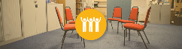















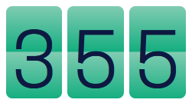

**PayPal link for HP2030**

<form action="https://www.paypal.com/cgi-bin/webscr" method="post" target="_top">

<input type="hidden" name="cmd" value="_s-xclick">

<input type="hidden" name="hosted_button_id" value="67XM86HUNTMYS">

<input type="image" src="https://www.paypalobjects.com/en_US/i/btn/btn_buynowCC_LG.gif" border="0" name="submit" alt="PayPal - The safer, easier way to pay online!">

<img alt="" border="0" src="https://www.paypalobjects.com/en_US/i/scr/pixel.gif" width="1" height="1">

</form>

<https://www.paypal.com/cgi-bin/webscr?cmd=_s-xclick&hosted_button_id=67XM86HUNTMYS>

 

