Event #SS100538-11262020

## Jane Clark, CHES/MCHES #8110

Completed the following approved self-study program:

### **Healthy People 2030 in your work**

Date of Program Completion: November 2, 2020

Sponsored by Health Education Partners, a designated provider of continuing education contact hours (CECH) in health education by the National Commission for Health Education Credentialing, Inc.  This program is designated for Certified Health Education Specialists (CHES) and/or Master Certified Health Education Specialists (MCHES) to receive up to     12.0    total Category I continuing education contact hours.  Maximum advanced-level continuing education contact hours available are ___6.0___. ___12.0__ Continuing Competency credits are available.

|  |  |
| --- | --- |
| Total contact hours earned | 12.0 |
| Entry–level contact hours earned | 6.0 |
| Advanced-level contact hours earned | 6.0 |

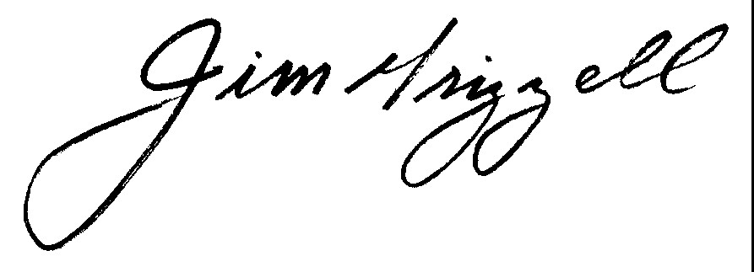

Jim Grizzell, MBA, MA, MCHES, ACSM-EP-C, F-ACHA

MCHES # 2670

Health Education Partners

Provider # 100538

# Certificate of Completion

