hp2020logo2.jpg

Using MAP-IT to “Assess“ for Healthy People 2020

Self-study continuing education course providing 8.0 Category 1 hours (includes 3.0 advanced)

|  |  |  |
| --- | --- | --- |
| General Information | Instructor:  Email:  Phone:  Course Materials: | Jim Grizzell, MBA, MA, MCHES, ACSM-HFS  [jim@healthedpartners.org](mailto:jim@healthedpartners.org)  909-856-3350 (cell, please call between 9 am - 8 pm PT  All materials are available online. |
| ***Course Description*** | This is a learning experience that will help the participant gain knowledge and build skills to do assessments for the implementation of [**Healthy People 2020**](http://healthypeople.gov). Healthy People 2020 offers MAP-IT as a framework for implementation (**M**obilize, **A**ssess, **P**lan, **I**mplement, **T**rack). This course covers the **Assess** section of that framework for Implementing Healthy People which draws upon free resources available from the [**Community Tool Box**](http://ctb.ku.edu/en/default.aspx). The MAP-IT framework helps create a path to a healthy community and Nation. The course includes a test and evaluation to be submitted for credit. | |
| ***Course Goals and Objectives*** | The goal is to prepare health professionals and partners assess needs and assets (resources) in the community. They will be able to help community members and key stakeholders determine what they see as the most important issues? And help them consider feasibility, effectiveness, and measurability as they determine priorities. | |
| ***Course Requirements*** | *Study Materials:* [**Healthy People 2020**](http://healthypeople.gov)web site and linked web pages and files, including the [**Community Tool Box**](http://ctb.ku.edu/en/default.aspx)  *Q10-Question Assessment* (passing is ≥70%)  *Course Evaluation* (included at the end of the assessment) | |
| **The entire course will be done electronically using the web and email.**  Here is the link to this course’s syllabus, materials and resources:  [www.healthedpartners.org/ceu/hp2020mapitassess/hp2020mapitassessstudyguide.pdf](http://www.healthedpartners.org/ceu/hp2020mapitassess/hp2020mapitassessstudyguide.pdf)  **10-question multiple choice and text response post-course assessment (required)**  [www.healthedpartners.org/ceu/hp2020mapitassess/hp2020mapitassesstest.pdf](http://www.healthedpartners.org/ceu/hp2020mapitassess/hp2020mapitassesstest.pdf) | | |
| ***Course Completion Certificate\**** | Course completion certificate for 8.0 CECHs for CHES (includes 3 advanced-level CECHs for MCHES, continuing education contact hours after) will be awarded if a score of ≥70% is achieved and course evaluation is completed. Payment of fee is required. | |

**Contents**

Introduction 2

Objectives and Assignments 3-5

Additional Materials and Resources – Bibliography and References 6

**Getting Started: Assess for Achieving Healthy People Goals**

The goal of this course is to help health professionals and people in agencies and organizations use the assess component of Healthy People 2020 and MAP-IT to implement Healthy People 2020. They will be able be effective users and expert consultants to find and explain tools and resources available on the Healthy People 2020 and The Community Tool Box (CTB) web sites to achieve the Nation’s health goals and objectives. They will have a very solid understanding of how to implement Healthy People 2020.

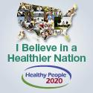

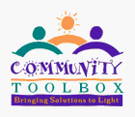The course covers the **Assess** section of **Implementing Healthy People**.

All of the materials to study and read are at these Healthy People 2020 web site links:

[www.healthypeople.gov](http://www.healthypeople.gov) and [www.healthypeople.gov/2020/implementing](http://www.healthypeople.gov/2020/implementing)

These are the graphics you will see and can click on to reach the pages.

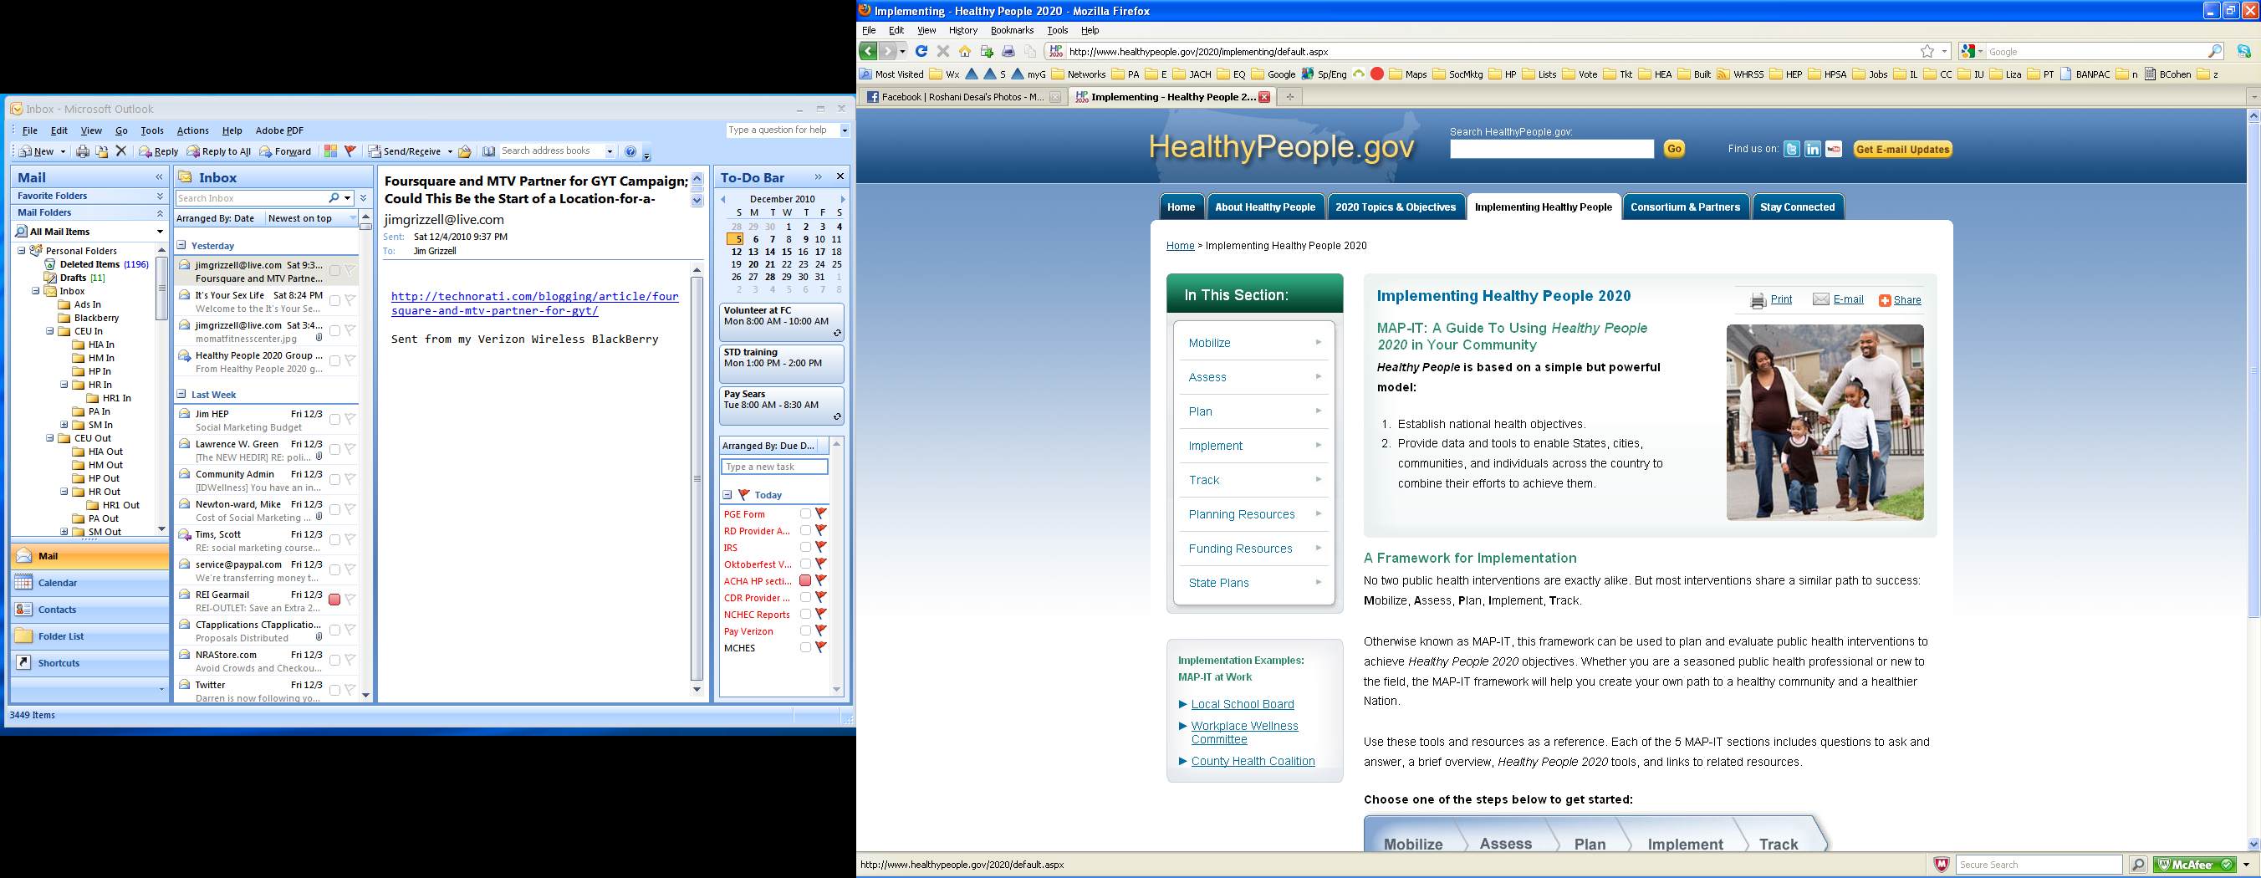

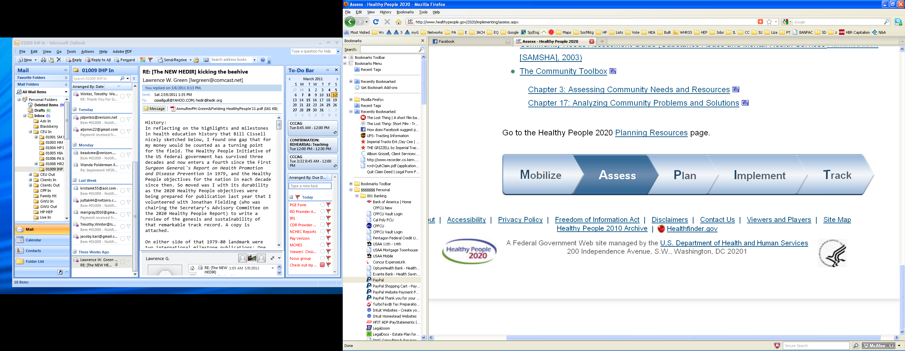

Throughout the “Study Guide” each study assignment can be opened from the electronic version / pdf file or from the Healthy People 2020 and the Community Toolbox web pages.

You will be asked to read each page and click on and read text from links on those pages. In all there are hundreds of pages of information, resources and tools beyond the original pages you will be asked to read and review.

The test has both multiple choice and short answer questions. Since there are more components to understanding how to mobilize than this nine hour course can cover you are not required to read every page. You will have the opportunity to select components you feel are most relevant to you. Be prepared to very briefly and concisely (≤50 words) describe the component you selected when you take the test.

**Opening the Study Assignments and Time Estimates**

1. Keep this Study Guide opened on your computer to be able to click on the links in the Study Guide.
2. Follow instructions on a printed copy to get to assignments.

Time to complete the course includes two components. 1) Estimated time to read text based on reading speeds of 250 words per minute (wpm) to faster speed at 300 wpm.

|  |  |
| --- | --- |
| **Estimated Time** | **Objectives and Assignments** |

|  |  |  |
| --- | --- | --- |
| ~0.5 hours | **Introduction**   |  | | --- | | Review this Study Guide (~30 min, shaded objectives relate to Master Certified Health Education Specialist advanced-level sub-competencies) | |
| ~0.5 hours | **Orientation to “Implementing Healthy People”**  **NOTE: this assignment is identical in each of the 6 MAP-IT Courses**  <http://www.healthypeople.gov/2020/implementing/default.aspx>  After studying the materials the participant will be able to:   |  | | --- | | 1. List the contents of the Implementing Healthy People 2020 page 2. Define framework for implementation: MAP-IT 3. List Planning Resources to help plan interventions 4. Describe the how to make the case and resources for funding and obtain program support 5. Provide expert assistance on planning and resources |   **Study Assignments**   |  | | --- | | * **Implementing Healthy People 2010** - read text on main/center portion of the page (<5 min, do not read text from Mobilize, Assess, Plan, Implement or Track at this time) * **Implementation Examples: MAP-IT at Work** - click on and read the text of each example in the lower left of the page: Local School Board, Workplace Wellness Committee and County Health Coalition (~15 min) * **Planning Resources** – click on the heading on the left or lower portion of the page and read text on the main/center portion of the Planning Resources page (<5 min) * **Funding Resources** - click on the heading on the left or lower portion of the page and read text on the main/center portion of the Funding Resources page (<10 min) | |
| ~1.0 hours | **Orientation to Assessing**  <http://www.healthypeople.gov/2020/implement/assess.aspx>  After studying the materials the participant will be able to:   |  | | --- | | 1. List questions to ask 2. Assess needs and assets (resources) for any group with something in common 3. Describe how to lead stakeholders and a coalition in assessment to set priorities 4. Explain how to get to roots of an issue considering social determinants of health | |  |   **Study Assignments for Assess Page**   |  | | --- | | * **Assess Web Page** - read the text on the page (~ 5 min) * **Brainstorm: Community Assets** – from the right side of the page click on to open and read the pdf file (<5 min) * **Exercise: Prioritizing Issues a Coalition -** click on to open and read the pdf file (<5 min) * **Community Health Assessment and Group Evaluation (CHANGE) Action Guide** – from the **Other Resources:** near the lower part of the page click on, <http://www.cdc.gov/healthycommunitiesprogram/tools/change/downloads.htm> and read the page, you do not need to explore links from the page (~25 min) * **10 Steps to Promoting Science-Based Approaches to Teen Pregnancy Using Getting to Outcomes: A Summary** –[www.cdc.gov/TeenPregnancy/PDF/LittlePSBA-GTO.pdf](http://www.cdc.gov/TeenPregnancy/PDF/LittlePSBA-GTO.pdf) download and read the pdf file (~25 min) | |
| ~1.5 hours | **Orientation to Community Tool Box and MAP-IT**  **NOTE: this assignment is identical in each of the 6 MAP-IT Courses**  After studying the materials the participant will be able to:   |  | | --- | | 1. Describe The Community Toolbox, and provide expert assistance on a model of practice as a planning model; and core principles, assumptions, and values to guide the work | |  |   **Study Assignments for Community Tool Box and MAP-IT**   |  | | --- | | * **The Community Toolbox –** read text on the CTB home page (<http://ctb.ku.edu/en/default.aspx>) (~ 5 min, for purposes of this course you do not need to click on and read links pages) * **Chapter 1:** **Our Model for Community Change and Improvement** <http://ctb.ku.edu/en/tablecontents/chapter_1001.htm>   + **Section 1. A Community Tool Box Overview and Gateway to the Tools** – read the Main Section, Examples, Related Topics (titles only), Tools & Checklist, PowerPoint (~25 min, read text on the section’s pages only, for purposes of this course you do not need to read text on linked pages)   + **Section 3. Our Model of Practice: Building Capacity for Community and System Change** – read the Main Section, Examples, Related Topics (titles only), Tools & Checklists, PowerPoint (~35 minutes)   + **Section 6**. Core Principles, Assumption, and Values to Guide the Work - read the Main Section, Examples, Related Topics (titles only), Tools & Checklists, PowerPoint (~30 minutes) | |
| ~2.0 | **MAP-IT: Assess – Chapter 3. Assessing Community Needs and Resources**  <http://ctb.ku.edu/en/tablecontents/chapter_1003.htm>  After studying the materials the participant will be able to:   |  | | --- | | 1. Explain how to develop a plan for identifying local needs and resources 2. Explain how to understand and describe the community 3. Describe how to collect information about the problem 4. Explain how to analyze community problems related to learning and skill building | |  |   **Study Assignments for Chapter 3**   |  | | --- | | * **Section 1. Developing a Plan for Identifying Local Needs and Resources** – read the Main Section, Examples, Related Topics (titles only), Tools & Checklist, PowerPoint (~15 min, read text on the section’s pages only, for purposes of this course you do not need to read text on linked pages) * **Section 2. Understanding and Describing the Community** – read the Main Section, Examples, Related Topics (titles only), Tools & Checklists, PowerPoint (~25 minutes) * **Section 3. Conducting Public Forums and Listening Sessions** – read the Main Section, Examples, Related Topics (titles only), Tools & Checklists, PowerPoint (~15 minutes) * **Section 4. Collecting Information About the Problems** - read the Main Section, Examples, Related Topics (titles only), Tools & Checklists, PowerPoint (~20 minutes) * **Section 5. Analyzing Community Problems** - read the Main Section, Examples, Related Topics (titles only), Tools & Checklists, PowerPoint (~20 minutes) * **Section 6, 7, 8, 9, 10, 11, 12, 13, 14, 15, 16, 17, 18 or 19** – ***select one*** of these sections and read the Main Section, Examples, Related Topics (titles only), Tools & Checklists, PowerPoint (~30 minutes, be prepared to state the name of the section your read and briefly (≤50 words) describe the content of the section in the course’s test) | |
| ~2.0 hours | **MAP-IT: Assess – Chapter 17. Analyzing Community Problems and Solutions**  <http://ctb.ku.edu/en/tablecontents/chapter_1017.htm>  After studying the materials the participant will be able to:   |  | | --- | | * List parts of and describe the problem solving process * Explain the importance of critical thinking * Define and analyze problems * Identify and analyze factors that foster and hinder learning and skill building (determine root causes of problems using the “But Why?” Technique) * Identify and analyze social determinants of health as factors of learning and skill building | |  |   **Study Assignments for Chapter 17**   |  | | --- | | * **Section 1. An Introduction to the Problem Solving Process** – read the Main Section, Examples, Related Topics (titles only), Tools & Checklist, PowerPoint (~10 min, read text on the section’s pages only, for purposes of this course you do not need to read text on linked pages) * **Section 2. Thinking Critically** - read the Main Section, Examples, Related Topics (titles only), Tools & Checklists, PowerPoint (~40 minutes) * **Section 3**. **Defining and Analyzing the Problem** - read the Main Section, Examples, Related Topics (titles only), Tools & Checklists, PowerPoint (~15 minutes) * **Section 4**. **Analyzing Root Causes of Problems** - read the Main Section, Examples, Related Topics (titles only), Tools & Checklists, PowerPoint (~10 minutes) * **Section 5**. **Addressing Social Determinants of Health and** Development - read the Main Section, Examples, Related Topics (titles only), Tools & Checklists, PowerPoint (~40 minutes) | |
| ~0.5 hour | **Take test and answer evaluation questions** (pdf form)  [www.healthedpartners.org/ceu/hp2020mapitassess/hp2020mapitassesstest.pdf](http://www.healthedpartners.org/ceu/hp2020mapitassess/hp2020mapitassesstest.pdf)  **Before or after immediately after taking the test be sure to save the test pdf file/form to a directory or folder on your computer.** Remember where it is. Do this for two reasons: 1) for your records and 2) depending on your email program you may need to send the file as an attachment. If you use gmail, aol, yahoo, etc. not in conjunction with Microsoft Office Outlook you need need to save the file to attached. Using MS Outlook allows you to click on a submit button to send the answers. Either way is acceptable |

**Additional Optional Course Materials and Resources**

**Bibliography and References**

Green, L., Fielding, J. **The u.s. healthy people initiative: its genesis and its sustainability**. (draft). Annual Review of Public Health. To be published March 2011.

Draft available at:

[www.csupomona.edu/~jvgrizzell/healthypeople/greenfieldinggenesishistoryhealthypeopleinitiative.pdf](http://www.csupomona.edu/~jvgrizzell/healthypeople/greenfieldinggenesishistoryhealthypeopleinitiative.pdf)

**Phase II Healthy People 2020 Advisory Committee Webinar/Calls and Meetings**

This link has all the agendas, slide presentations, reports for meetings since February 2009.

<http://www.csupomona.edu/~jvgrizzell/hc2020/hp2020accallsmeeting.htm>

As an example the following shows the files available for the April 2010 meeting.

[**April 2010**](http://www.csupomona.edu/%7Ejvgrizzell/hc2020/091211call/)

* [Agenda](http://www.healthedpartners.org/hc2020/100401call/Agenda_04.01.10_PUBLIC.pdf) (pdf)
* [Meeting Slides](http://www.healthedpartners.org/hc2020/100401call/1_faca_meeting_slides_4_1_2010_final.ppt) (15 slides, pdf)
* [Webinar](https://odphp-events.webex.com/odphp-events/lsr.php?AT=pb&SP=EC&rID=15717732&rKey=330c51105f89f269)(view and listen to the 2 hour meeting call online)
* Healthy People's Connection to Health Reform
  + [Health Promotion Opportunities from Health Reform](http://www.healthedpartners.org/hc2020/100401call/2_1_health_promotion_opportunities_health_reform_arra.pdf) (4 pages, pdf)
  + [HR3590 Title IV](http://www.healthedpartners.org/hc2020/100401call/2_2_HR3590_Title%20IV.pdf) (9 pages, pdf)
* [How HHS can Shape Healthy People to Prompt Action on Social and Environmental Determinants of Health](http://www.healthedpartners.org/hc2020/100401call/3_1_adhoc_social_determ-rec_edits_3%2018%2010_final.pdf) (5 pages, pdf)
* [Recommendations for Priority Setting](http://www.healthedpartners.org/hc2020/100401call/3_2_priorities_recommendations_draft_demo_3_30_2010.pdf) (8 pages .pdf)
* [Recommendations from Subcommittee on Strategic Communications on Communication and Implementation of HP2020](http://www.healthedpartners.org/hc2020/100401call/3_3_hp2020_recommendations_from_strategic_communications_3-16-10.pdf) (1 page, pdf)
* [Communicating about HP2020 with Key Audiences](http://www.healthedpartners.org/hc2020/100401call/3_4_hp2020_key_audiences_updated_version_03.29.10.pdf) (4 page table, pdf)
* HP2010 User Assessment
  + [Use Study One-page Summary](http://www.healthedpartners.org/hc2020/100401call/4_1_hp2010_users_assessment_1-pg.pdf) (pdf)
  + [User Study Presentation](http://www.healthedpartners.org/hc2020/100401call/2_April%201%20HP%20Users%20Study%20Slides_NORC.pdf) (14 slides, pdf)

**Healthy People 2020 Webinar**

Sponsored by IDWellness and HP Career Net on Oct 2, 2009

* Webinar
  + <http://vimeo.com/6886306>
* PowerPoint Slides
  + [www.healthedpartners.org/hc2020/hp2020webinarwnotes.pdf](http://www.healthedpartners.org/hc2020/hp2020webinarwnotes.pdf)