Health Impact Assessment

Assess Potential Effects of Policies, Programs and Projects

A self-study distance continuing education course providing 6.5 Category 1 CECHs

|  |  |  |
| --- | --- | --- |
| General Information | Instructor:  Email:  Phone:  Project Tools: | Jim Grizzell, MBA, MA, CHES, ACSM-HFS  [jim@healthedpartners.org](mailto:jim@healthedpartners.org)  909-856-3350 (cell, please call between 8 am - 9 pm ET  All materials available online |
| ***Course Description*** | This is a self-study learning experience using text and audio files available online about health impact assessments (HIA). This course assumes little or no experience or knowledge of HIAs. It does emphasize 1) the HHS Healthy People 2020 Advisory Committee recommendations to use HIAs to achieve national goals and 2) history and processes of conducting HIAs. | |
| ***Course Goals and Objectives*** | * Describe the history and background of HIAs * List organizations promoting use of HIAs * Describe the types and process of doing HIAs * Explain how HIAs have been and can be used in the US in the future * Select and explain the rationale for the selection of guides for doing HIAs | |
| ***Course Requirements*** | *Study Materials:* Journal articles, Guides and web pages in choices of text or speech  *19-Question Assessment* (pass with ≥70% (13+) correct)  *Course Evaluation* | |
| **The entire course will be done electronically using the web and email.**  Here is are links to a page with this Study Guide:  [www.healthedpartners.org/ceu/hia](http://www.healthedpartners.org/ceu/hia) & [www.healthedpartners.org/ceu/hia/hiastudyguide.pdf](http://www.healthedpartners.org/ceu/hia/hiastudyguide.pdf)  **19-question multiple choice post-course assessment (required)**  [www.healthedpartners.org/ceu/hia/hiatestform.pdf](http://www.healthedpartners.org/ceu/hia/hiatestform.pdf)  **Course Evaluation (required)**  <http://www.surveymk.com/s/hiacourseevaluation> | | |
| ***Course Completion Certificate*** | Course completion certificate for 6.5 CECHs (continuing education contact hours) will be awarded if a score of ≥70% (xx of xx) is achieved and the Course Evaluation is completed. Payment of fee is required. | |

**Contents**

Introduction 2

Objectives and Assignments 3-5

Hints to Download, Read, Listen to and Do Key Word Searches of Course Materials 6

Additional Materials and Resources 7

**Introduction**

The goal of this course is to help health educators and others be able to use what is becoming recognized as a powerful tool to prevent harm and maximize benefits to people. HIA is a practical approach used to judge the potential health effects of a policies, programs or projects on a population. Recommendations are produced for decision-makers and stakeholders, with the aim of maximizing the proposal's positive health effects and minimizing its negative health effects.

The course has four main sections. After the introduction the first provides a background using the WHO Gothenburg Consensus Paper which is referenced by all other organizations. You will get information from global, national and local perspectives. The second section will help you understand the importance and recommendation to use HIAs in the United States with an emphasis on achieving Healthy People 2020 goals. The third section gives a rational and standards for HIA use and reports. The fourth section will allow you to review and select a guide to doing HIAs or combination of guides to help you achieve your local or organization goals.

**An Approach to Health Impact Assessment**

Gothenburg Consensus Paper, December 1999



**NOTE:** You have 2 ways to “read” the text of files, articles and web pages. You can choose to read text from pdf files or web pages. You can also listen to the same text of most pdf and html files via MP3/Audio files. See page 5 if you would like hints and help using the pdf, html and mp3/audio files.

|  |  |
| --- | --- |
| **Estimated Time** | **Objectives and Assignments** |
| ~0.25 hours | **Introduction**   |  |  |  | | --- | --- | --- | | * Review this Study Guide (~15 min) |  |  | |
| ~1.5 hours | **Section 1: HIA Background and Basics**  After studying the materials the participant will be able to:   |  |  |  | | --- | --- | --- | | * Describe the history and background of HIAs |  |  | | * Name organizations leading the way for HIAs |  |  | |  |  |  |   **Reading and/or Listening Assignments**   |  |  |  | | --- | --- | --- | | * Importance of using HIA in the US and for Healthy People 2020 Goals and Objectives (~22 min) | [PDF](http://www.healthedpartners.org/ceu/hia/hia01/01_01_introduction_hia.pdf) | [AUDIO](http://www.healthedpartners.org/ceu/hia/hia01/01_01_introduction_hia.mp3) | | * Health Impact Assessment: main concepts and suggested approach *Gothenburg consensus paper, December 1999*  (referenced by all leading HIA proponents, ~15 min) | [PDF](http://www.healthedpartners.org/ceu/hia/hia01/01_02_gothenburg_paper_on_hia_1999.pdf) | [AUDIO](http://www.healthedpartners.org/ceu/hia/hia01/01_02_gothenburg_paper_on_hia_1999.mp3) | | * World Health Organization HIA web page (selected text, ~30 min) | [PDF](http://www.healthedpartners.org/ceu/hia/hia01/01_03_who_hia_web_page.pdf) | [AUDIO1](http://www.healthedpartners.org/ceu/hia/hia01/01_03_who_hia_web_page-1.mp3)  [AUDIO2](http://www.healthedpartners.org/ceu/hia/hia01/01_03_who_hia_web_page-2.mp3) | | * CDC HIA Fact Sheet (~5 min) | [PDF](http://www.healthedpartners.org/ceu/hia/hia01/01_04_cdc_hia_web_page_fact_sheet.pdf) | [AUDIO](http://www.healthedpartners.org/ceu/hia/hia01/01_04_cdc_hia_web_page_fact_sheet.mp3) | | * National Association of County & City Health Officials (~15 min) | [PDF](http://www.healthedpartners.org/ceu/hia/hia01/01_05_naccho_hia_guide.pdf) | [AUDIO](http://www.healthedpartners.org/ceu/hia/hia01/01_05_naccho_hia_guide.mp3) | |
| ~1.5 hours | **Section 2: The Future of HIA in the US**  After studying the material in this section the participant will be able to:   |  | | --- | | * Describe the history and trends for HIA use in the US * Explain how policy makers might be persuaded to use HIAs | |  |   **Reading and/or Listening Assignments**   |  |  |  | | --- | --- | --- | | * Methodologies for Realizing the Potential of Health Impact Assessment (~17 min) | [PDF](http://www.healthedpartners.org/ceu/hia/hia02/02_01_methodologies_realizing_potential_hia_2005.pdf) | [AUDIO](http://www.healthedpartners.org/ceu/hia/hia02/02_01_methodologies_realizing_potential_hia_2005.mp3) | | * Growing the Field of Health Impact Assessment in the United States: An Agenda for Research and Practice of HIAs (~22 min) | [PDF](http://www.healthedpartners.org/ceu/hia/hia02/02_02_growing_field_of_hias_in_us_2006.pdf) | [AUDIO](http://www.healthedpartners.org/ceu/hia/hia02/02_02_growing_field_of_hias_in_us_2006.mp3) | | * Use of Health Impact Assessment in the U.S. 27 Case Studies, 1999–2007 (~16 min) | [PDF](http://www.healthedpartners.org/ceu/hia/hia02/02_03_ajpm_27hiacasestudies_march_2008.pdf) | [AUDIO](http://www.healthedpartners.org/ceu/hia/hia02/02_03_ajpm_27hiacasestudies_march_2008.mp3) | | * Recommendations Building Health Impact Assessment (HIA) Capacity: A Strategy for Congress and Government Agencies, A Prevention Policy Paper Commissioned by Partnership for Prevention (~36 min) | [PDF](http://www.healthedpartners.org/ceu/hia/hia02/02_04_partnerships4prevention_strategy_for_congress_hia_2008.pdf) | [AUDIO1](http://www.healthedpartners.org/ceu/hia/hia02/02_04_partnerships4prevention_strategy_for_congress_hia-1.mp3)  [AUDIO2](http://www.healthedpartners.org/ceu/hia/hia02/02_04_partnerships4prevention_strategy_for_congress_hia-1.mp3)  [AUDIO3](http://www.healthedpartners.org/ceu/hia/hia02/02_04_partnerships4prevention_strategy_for_congress_hia-1.mp3) | |
| ~1.75 hours | **Section 3: The Future has Arrived – Recommendations and Guidelines**  After studying the material in this section the participant will be able to:   |  | | --- | | * Describe the Minnesota Department of Health’s strategy for using HIAs * Discuss "standards for practice" for each of the five typical stages * List anticipated influencing factors and health determinants and outcomes of specific types of resource development projects * Explain standards for reviewing reports of HIAs to ensure reports are fit for purpose and comply with best practice | |  |   **Reading and/or Listening Assignment**   |  |  |  | | --- | --- | --- | | * Minnesota Department of Health A Call to Action (read Executive Summary, pages 1-8; Recommendations and Strategies for Implementation, pp 39-52) (~28 min) | [PDF](http://www.healthedpartners.org/ceu/hia/hia03/03_01_minnesota_doh_call_to_action_hia.pdf) | [AUDIO1](http://www.healthedpartners.org/ceu/hia/hia03/03_01_minnesota_doh_call_to_action_hia-2.mp3)  [AUDIO2](http://www.healthedpartners.org/ceu/hia/hia03/03_01_minnesota_doh_call_to_action_hia-2.mp3) | | * North American HIA Practice Standards Working Group Practice Standards (~15 min) | [PDF](http://www.healthedpartners.org/ceu/hia/hia03/03_02_hia_practice_standards.pdf) | [AUDIO](http://www.healthedpartners.org/ceu/hia/hia03/03_02_hia_practice_standards.mp3) | | * An Health Effects Assessment Tool (HEAT): Innovative Guide for HIA in Resource Development Projects (note that the audio does not include text in the 10 tables – please read text in the hard PDF file) (~45 min) | [PDF](http://www.healthedpartners.org/ceu/hia/hia03/03_03_heat.pdf) | [AUDIO](http://www.healthedpartners.org/ceu/hia/hia03/03_03_heat.mp3) | | * A review package for Health Impact Assessment reports of development projects (~18 min) | [PDF](http://www.healthedpartners.org/ceu/hia/hia03/03_04_hia_report_review_guide.pdf) | [AUDIO](http://www.healthedpartners.org/ceu/hia/hia03/03_04_hia_report_review_guide.mp3) | |  |  |  | |
| ~1.25 hours | **Section 4: HIA Tools and Guide Samples**  After studying the material in this section the participant will be able to:   |  | | --- | | * Select and explain rationale for using or adapting HIA tools, checklists, worksheets and sample outlines with the participant’s work setting, community or population. | |  |   **Reading and/or Listening Assignment**   |  |  |  | | --- | --- | --- | | * HIA Workbooks (these have worksheets, matrices, checklists or sample outlines – sometime in the body of the file but often in appendices) | | | | INSTRUCTIONS – review, do not necessarily read all content. Review to evaluate and consider for adaptation of the tools for use in your work setting. Much of the beginning of each explains main concepts of HIAs which were covered in previous sections. Look for the worksheets, checklists and outlines. |  |  | | * + Introduction to HIA, International Finance Group, World Bank Group (2009) (~18 min) |  | [PDF](http://www.healthedpartners.org/ceu/hia/hia04/04_01_ifcworldbank_hia_guide_2009.pdf) | | * + Health Impact Assessment Guidance, Ireland, 2009 (~18 min) |  | [PDF](http://www.healthedpartners.org/ceu/hia/hia04/04_02_ireland_hia_guide_2009.pdf) | | * + A Guide to HIAs – Focusing on Social and Environmental sustainability: Swedish National Institute of Public Health (2005) (~18 min) |  | [PDF](http://www.healthedpartners.org/ceu/hia/hia04/04_03_swedish_hia_guide_2005.pdf) | | * + HIA: A Practical Guide, New Zealand (2007) (~18 min) |  | [PDF](http://www.healthedpartners.org/ceu/hia/hia04/04_04_australia_nz_hia_practical_guide_2007.pdf) | |
| ~0.25 hours | **Take test and complete evaluation**   |  |  |  | | --- | --- | --- | | * 19-question test | [PDF Form](http://www.healthedpartners.org/ceu/hia/hiatestform.pdf)* | | | * Course evaluation |  | [HTML](http://www.surveymk.com/s/hiacourseevaluation) | |  |  |  | | * This is an Adobe PDF Form. Download the form and save it to your computer. When it is open answer the questions. Your total score will be on the last page. You can change your answers. To submit your answers click on the “Submit” button in the upper right corner of the window the form is in. The data will be sent using one of 2 email programs: if you use MS Outlook the data will be sent automatically or 2) if you use another program like gmail or yahoo you must save the form with your answers, attach it to an email and send the form to [ce@healthedpartners.org](mailto:ce@healthedpartners.org). Select the appropriate radio button for the type of email program you want to use.  Email Form Dialogue 2.jpg |  |  | |

**Hints to Download, Read, Listen to and Do Key Word Searches of Course Materials**

**PDF and HTML Files**

You’ll need Adobe Reader or another program that opens pdf files. Permalinks in the Division assignments that follow take you to the Congressional Research Service online version.

To open these files click the left button of your mouse. Be sure you are connected to the internet

To save files to your computer click the right button and follow instructions on the screen.

**AUDIO Files**

These are the same text from articles and web pages. They are spoken at about 125 words per minute so listening time is about twice that of reading the pdf files or web pages. The text can sound awkward since it is converted to speech using text-to-speech software. Also, text may have gone through several conversions from pdf to Word to plain text before conversion to speech. As a result some words are not pronounced the way we’re familiar. A suggestion is to listen for the concepts in the article and try to ignore the voice.

What to Use for Listening: Audio files read from assignment text are in mp3 format. You can listen to these with many programs such as Windows Media Player, RealPlayer or QuickTime. If you prefer to listen to these you may need to set options on your browser to open in a specific one or download and save to your hard drive. Also, download to listen on an Ipod or an Iphone.

To open these files click the left button of your mouse. Be sure you are connected to the internet.

To save files to your computer click the right button and follow instructions on the screen.

**Search within PDF Documents and Web Pages**

If you would like help on this please go to pages 9 - 11 for instructions.

**Additional Optional Course Materials and Resources**

The following are from the CDC HIA web page [www.cdc.gov/healthyplaces/hia.htm](http://www.cdc.gov/healthyplaces/hia.htm)

**HIA General Information and Clearinghouses**

* [The UCLA Health Impact Assessment Clearinghouse Learning and Information Center[External Web Site Icon](http://www.ph.ucla.edu/hs/hiaclic/)](http://www.ph.ucla.edu/hs/hiaclic/)  
  This Website is designed to collect and disseminate information on health impact assessment (HIA) in the United States. The Website has summaries of HIAs conducted in the U.S., reviews of common pathways examined by HIAs, HIA-related news, and information about HIA methods and tools.
* [World Health Organization Health Impact Assessment[External Web Site Icon](http://www.who.int/hia/en/)](http://www.who.int/hia/en/)  
  This site provides general information about HIA, tools and methods to complete HIAs, examples of completed HIAs, discussion of the role of HIA in decision making, and information about the evidence base that can be used for HIAs.
* [Health Impact Assessment Gateway[External Web Site Icon](http://www.hiagateway.org.uk/)](http://www.hiagateway.org.uk)  
  This extensive site, created by the Health Development Agency in England, includes general information on HIA, networking, upcoming training and conferences, resources available to complete HIAs, and completed HIAs.
* [Health Impact Project[External Web Site Icon](http://www.healthimpactproject.org/hia)](http://www.healthimpactproject.org/hia)
* Kemm J, Parry J & Palmer S (2004) *Health Impact Assessment: Concepts, theory, techniques and applications*, Oxford University Press, [ISBN 0198526296.[External Web Site Icon](http://en.wikipedia.org/wiki/Special:BookSources/0198526296)](http://en.wikipedia.org/wiki/Special:BookSources/0198526296)
* [National Association of County and City Health Officials[External Web Site Icon](http://www.naccho.org/topics/environmental/landuseplanning/HIA.cfm)](http://www.naccho.org/topics/environmental/landuseplanning/HIA.cfm)

**On-line Courses and University Education**

* [Planning for Healthy Places with Health Impact Assessments[External Web Site Icon](http://professional.captus.com/Planning/hia/default.aspx)](http://professional.captus.com/Planning/hia/default.aspx)  
  This online course explains the value of conducting an HIA and the steps involved in conducting an HIA. The course, developed by the American Planning Association and the National Association of County & City Health Officials, was funded by the Centers for Disease Control and Prevention.
* [UC Berkeley Health Impact Group[External Web Site Icon](http://sites.google.com/site/ucbhia/)](http://sites.google.com/site/ucbhia/)  
  The UC Berkeley Health Impact Group (UCBHIG) is a non-partisan, independent collective whose mission is to promote the field of Health Impact Assessment through advocacy, education, research, and community outreach. UCBHIG’s work focuses largely on the development of qualitative and quantitative tools.
* Botchwey N, Hobson S, Dannenberg AL, Mumford KG, Contant CK, McMillan TE, Jackson RJ, Lopez R, Winkle C. [A Model Built Environment and Public Health Course Curriculum: Training for an Interdisciplinary Workforce Adobe PDF file [PDF - 104 KB][External Web Site Icon](http://www.activelivingresearch.org/files/12.ModelCurriculum_Botchwey.pdf)](http://www.activelivingresearch.org/files/12.ModelCurriculum_Botchwey.pdf). American Journal of Preventive Medicine. 2009;36(2S):S63–S71.
* [Built Environment + Public Health : Course Curriculum[External Web Site Icon](http://faculty.virginia.edu/nbotchwey/BuiltEnvironmentandHealthCurriculum.htm)](http://faculty.virginia.edu/nbotchwey/BuiltEnvironmentandHealthCurriculum.htm)  
  This CDC-funded Web site an interdisciplinary undergraduate, graduate, or continuing education curriculum in public health and built environment. This curriculum is flexible enough to be offered as a full semester course, individual units or single class modules or individual assignments. This Web site also provides opportunity for faculty and other users to share comments, amendments and develop collaborations at the intersection of the built environment and health.

**Methodology, Tools, and Evidence for Practice**

* [Human Impact Partners[External Web Site Icon](http://www.humanimpact.org/)](http://www.humanimpact.org/)  
  A nonprofit project of the Tides Center, the purpose of this site is to raise awareness of and collaboratively use innovative data, processes and tools that evaluate health impacts and inequities in order to transform the policies, institutions and places people need to live healthy lives.
* [Healthy Development Measurement Tool[External Web Site Icon](http://www.thehdmt.org/)](http://www.thehdmt.org/)  
  This tool, created by San Francisco Department of Public Health, Program on Health, Equity and Sustainability, is a comprehensive evaluation metric to consider health needs in urban development plans and projects.
* [Design for Health[External Web Site Icon](http://www.designforhealth.net/techassistance/healthimpact.html)](http://www.designforhealth.net/techassistance/healthimpact.html)  
  A collaborative project between the [University of Minnesota[External Web Site Icon](http://www1.umn.edu/twincities/index.php)](http://www1.umn.edu/twincities/index.php), [Cornell University[External Web Site Icon](http://www.cornell.edu/)](http://www.cornell.edu/), and the [University of Colorado[External Web Site Icon](https://www.cu.edu/)](https://www.cu.edu/) that serves to bridge the gap between the emerging research base on community design and healthy living and the everyday realities of local government planning.

**HIA & Environmental Impact Assessment**

* Bhatia, R and Wernham, A. Integrating Human Health into Environmental Impact Assessment: An Unrealized Opportunity for Environmental Health and Justice. Environmental Health Perspectives. 2008;116(8): 991-1000. [http://www.ehponline.org/docs/2008/11132/abstract.html[External Web Site Icon](http://www.ehponline.org/docs/2008/11132/abstract.html)](http://www.ehponline.org/docs/2008/11132/abstract.html)

**HIA & Public Policy Development**

* [Health Impact Assessment Information & Insight for Policy Decisions[External Web Site Icon](http://www.ph.ucla.edu/hs/health-impact/)](http://www.ph.ucla.edu/hs/health-impact/)  
  This joint endeavor of the Partnership for Prevention and researchers at the UCLA School of Public Health aims to assess the feasibility of HIA and to develop prototype HIAs that demonstrate methodologies, eventually enabling HIA to contribute to more informed decision-making about public policies impacting health in the U.S.

**Key Word Search within PDF Document & Web Page**

**Browsers**

**Firefox Mozilla**

(from Help or go to <http://support.mozilla.com/en-US/kb/Searching+within+a+page?style_mode=inproduct&s=search>)

## Using the Find bar

To start searching for text on a page:

Open the Find bar:

* + Use the CtrlCmd+F keyboard shortcut.
  + Click on the **Edit** menu, then select Find.

Type a search phrase into the Find Bar's **Find:** field. Firefox will start highlighting instances of your search phrase as you type. 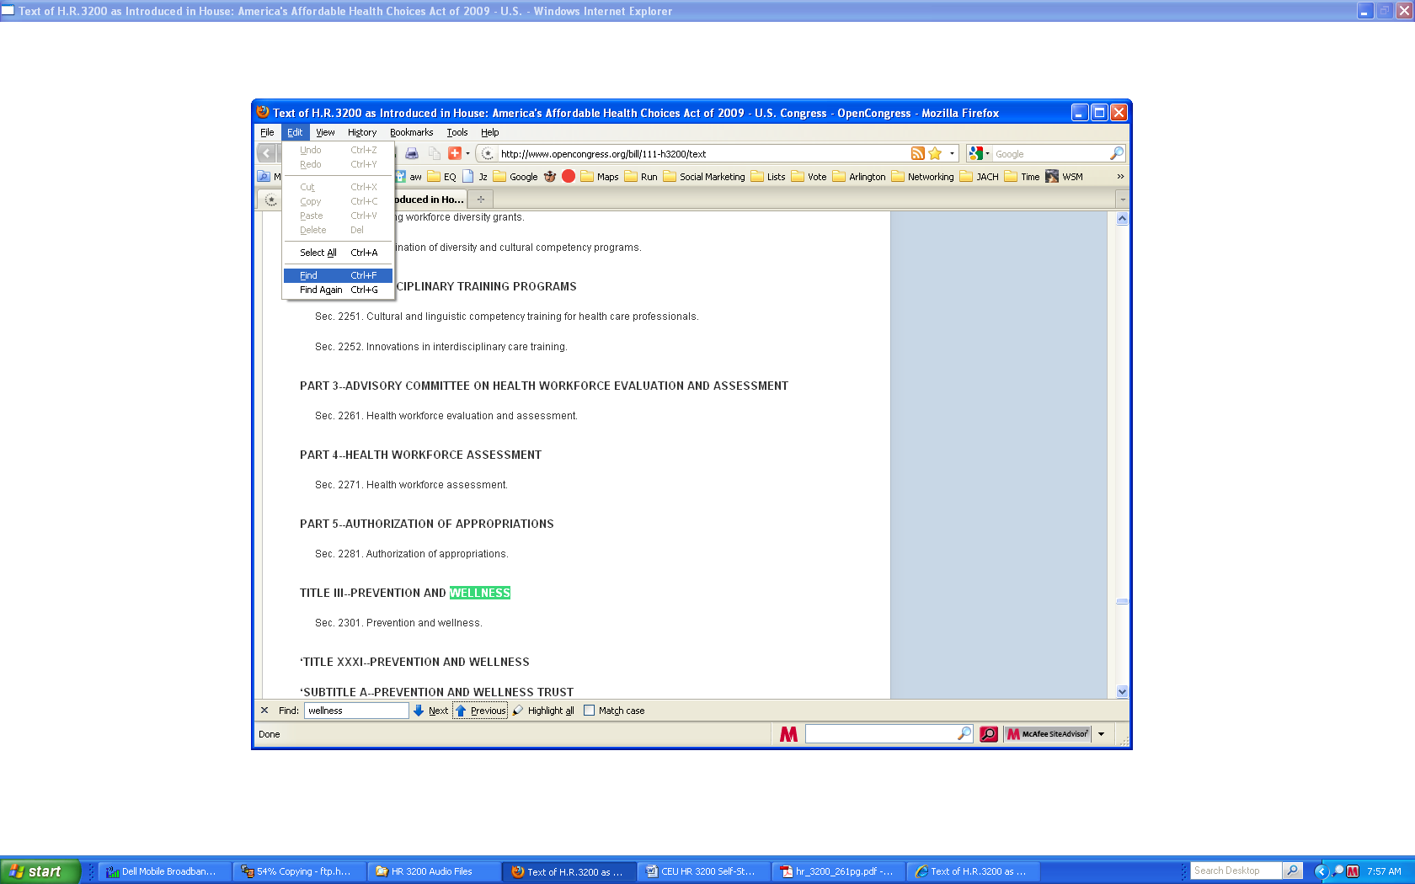

**Internet Explorer** (from IE Help)

To find information on a webpage

1. In Internet Explorer, click the **Edit** menu, and then click **Find on this Page** to display the text box on the tab row.
2. In the text box on the tab tow, type the word or phrase you want to find on this page. The number of matches found will appear next to the **Options** button, and the page will automatically scroll to the first occurrence of the word or phrase.
3. To go to the next or previous instance of the word or phrase, click the **Next** or **Previous** button.

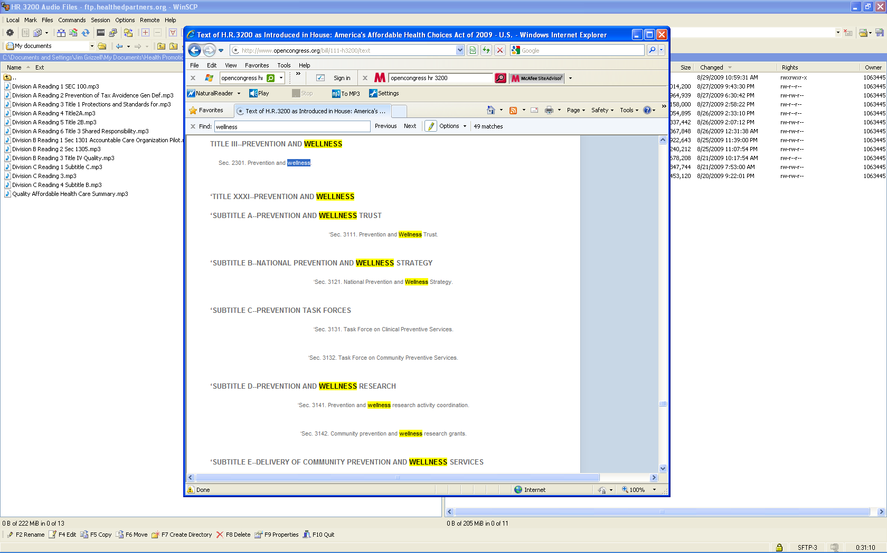

**Adobe PDF**

**Find text in a PDF**

The Find toolbar searches the currently open PDF.

1. Type the text you want to search for in the text box on the Find toolbar.

2. (Optional) Click the arrow next to the text box and choose one or more of the following:

3. Press Enter.

Acrobat jumps to the first instance of the search term, which appears highlighted.

4. Press Enter repeatedly to go to the next instances of the search term.

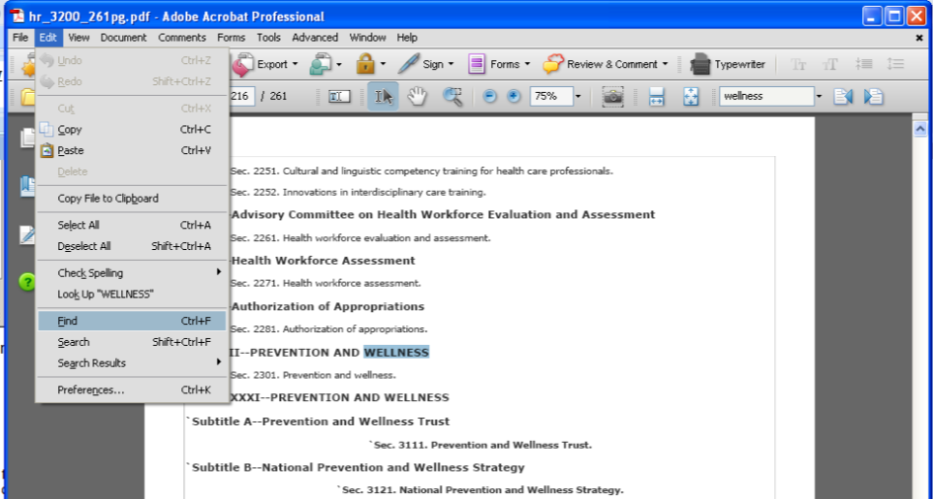

Describe the history and background of HIAs

List organizations promoting use of HIAs

Describe the types and process of doing HIAs

Explain how HIAs have been and can be used in the US in the future

Select and explain the rationale for the selection of guides for doing HIAs