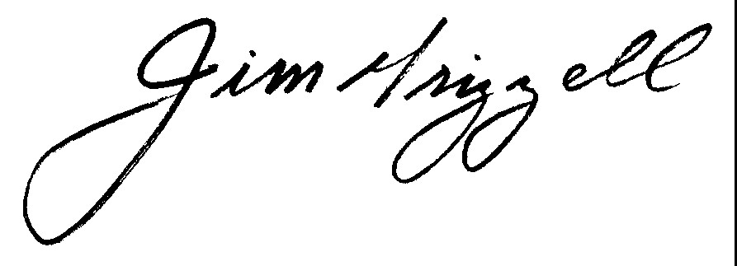

## Erica Cage, CHES/MCHES #20450

Completed the following approved self-study program:

### **Advocate for Health:**

**Build on the Progress of the Affordable Care Act**

Date of Program Completion:

April 7, 2017

Sponsored by Health Education Partners, a designated provider of continuing education contact hours (CECH) in health education by the National Commission for Health Education Credentialing, Inc.  This program is designated for Certified Health Education Specialists (CHES) and/or Master Certified Health Education Specialists (MCHES) to receive up to          10.0        total Category I continuing education contact hours.  Maximum advanced-level continuing education contact hours available are ______ _8.0________.

|  |  |
| --- | --- |
| Total contact hours earned | 10.0 |
| Entry–level contact hours earned | 2.0 |
| Advanced-level contact hours earned | 8.0 |

Jim Grizzell, MBA, MA, MCHES®, ACSM-EP-C, FACHA

MCHES # 2670

Event # TBA



Health Education Partners

Provider # 100538

# Certificate of Completion